Instructions for the user when working with the software application "mesh_generator"
This software is intended for the preparation of computational meshes (CM) with graduating and curved edges when performing numerical modeling of the problems of continuum mechanics on the basis of the OpenFOAM software environment. The software application "mesh_generator" provides the automation of creating a file of initial parameters of the CM "blockMeshDict", the process of generating a CM and visualization of the results of the generation of a CM through a package of scientific three-dimensional visualization of ParaView.
The program works as a desktop application and can be located in any directory of a computer running Linux. The distribution of the application "mesh_generator" contains six service directories and the executable file "run.py". The results of its launch are shown in fig. 1.
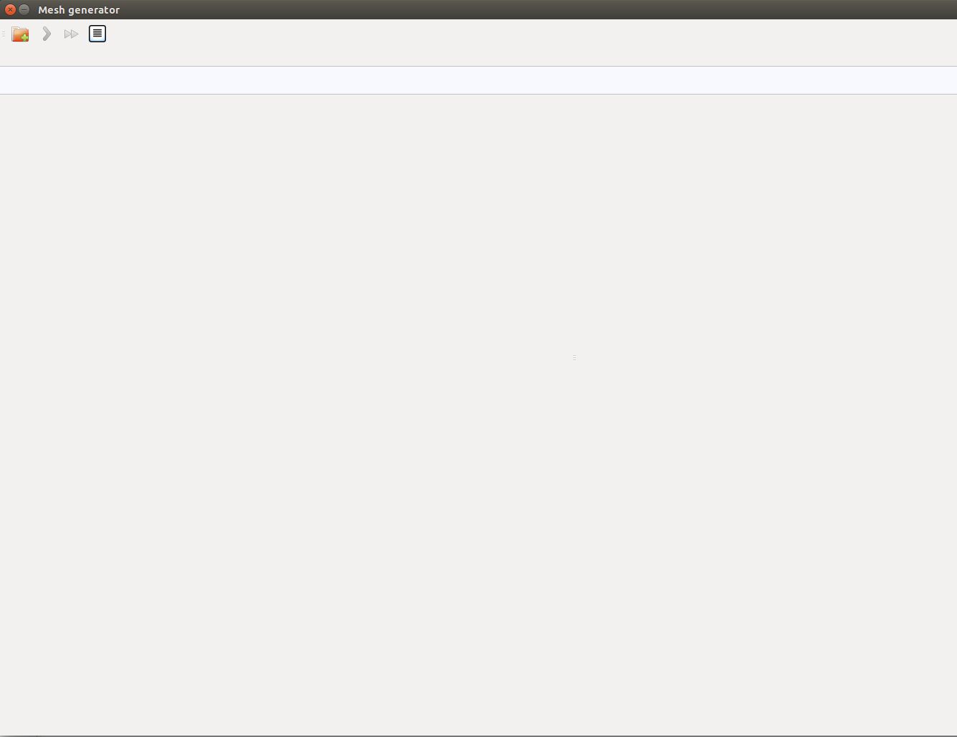
Fig. 1. The results of running the "run.py" file of the "mesh_generator" program
To build a CM with graduating and curved edges with the help of the application "mesh_generator" for working in the OpenFOAM, it is necessary to perform a number of steps:
1) use the "Select the interface language for the program" button (fig. 2) to open the corresponding window (fig. 3) and select the language version of the program: Russified or English (the default is Russified).

Fig. 2. Button for opening the program interface language selection window
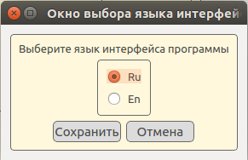
Fig. 3. The window for selecting the language of the program interface
2) use the "Open project" button (fig. 4) to open the window for selecting the directory of the calculated mesh (fig. 5). In this window, the user has two options for working with the program − creating a new CM or opening an existing one.

Fig. 4. Button to open the window for selecting the directory
When the checkbox "Create new" is selected, access to the fields containing the name of the CM and the path to it appears. Under the path to the mesh is understood the path to the "system" directory of the calculation case where the parameter file "blockMeshDict" should be located. For the "Mesh name" field, a validator is installed, which allows you to enter only English and Russian letters, an underscore and numbers from 0 to 9.
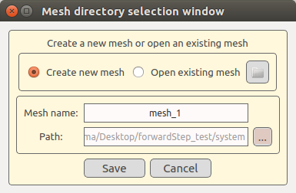
Fig. 5. The window for selecting the CM directory
There is no direct access to the "Path" field of the user. To determine the path value, open the path selection window (fig. 6) using the three-point button. In this case, the target directory must be called "system", otherwise an error message will be generated. The path selection window is the standard service window for selecting the directory for Linux OS.
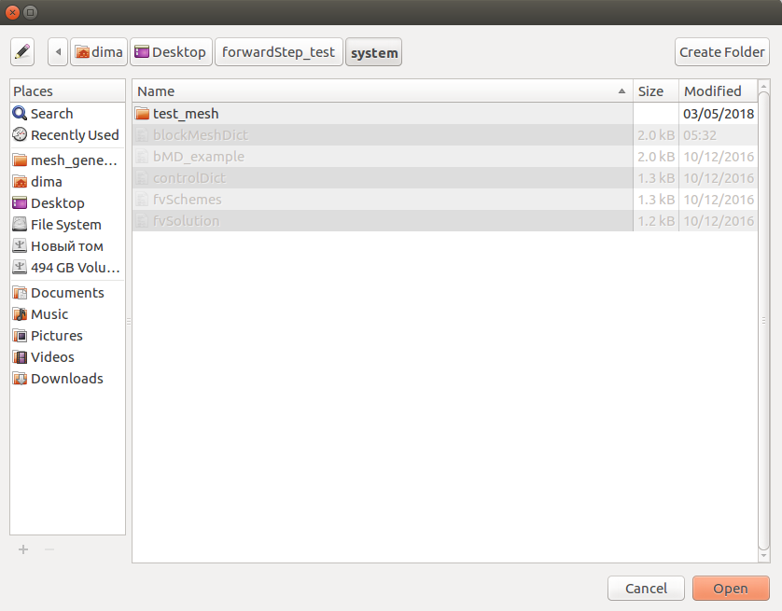
Fig. 6. The standard service window for selecting a directory
For example, there is a calculated case called "forwardStep_test", in which there is a standard set of folders: "0", "constant", "system". Since the CM parameter file "blockMeshDict" is located in the "system" directory, the directory with the set of service files of a specific CM created by the program "mesh_generator" is also located in the "system" folder. For example, for a mesh named "mesh_1", the CM directory will be called "mesh_1".
If you select the "Open existing" checkbox (fig. 5), the button for selecting the directory of one of the existing CM becomes available. When this button is clicked, the user sees the window as shown in fig. 5. It is worth noting that in the example presented in the "system" folder there is another mesh called "test_mesh". For example, its user can choose to edit. Thus, for any calculation case, any number of CM can be created. After selecting the directory of an existing CM, the user can change the name of the CM, and the value of the "Path" parameter will be determined automatically.
The "Save" button of the window is initially unavailable. Its state changes only after the user determines the CM directory. The result of saving the CM directory is the download in the main program window (fig. 7) of the window with the source data preparation block for the mesh, where a set of forms for editing the CM parameter blocks is displayed in accordance with the structure of the "blockMeshDict" file and the window of the service message output panel.
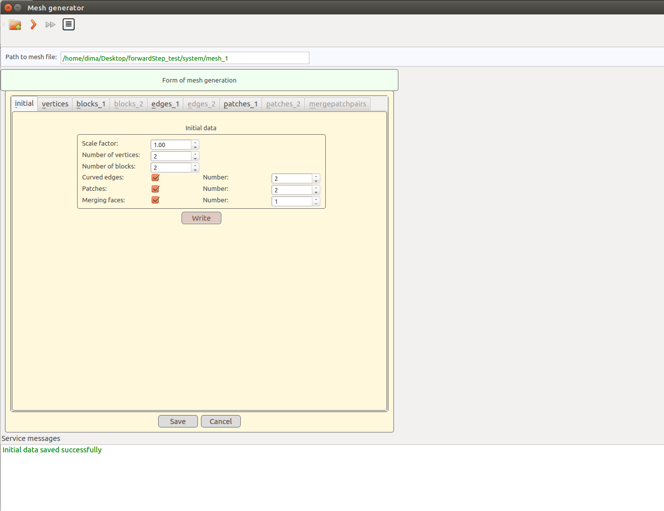
Fig. 7. The main program window after selecting the CM directory and pressing the "Save" button
The control panel of the program contains a field containing the full path to the selected CM directory. This field is closed for editing. Its contents are determined programmatically.
3) the third step is to fill the set of forms with the parameters that define the CM and are stored in the "blockMeshDict" file of the "system" folder of the calculation case.
"initial". This is the first form of the set, which defines the basic description of the CM. It involves specifying parameters such as the scale factor, the number of block heights (hexahedrons), the number of blocks, the presence of curved edges (and their number), the presence of patches (and their number), the presence of merging faces (and their number). An example of the completed form "initial" is shown in fig. 8.
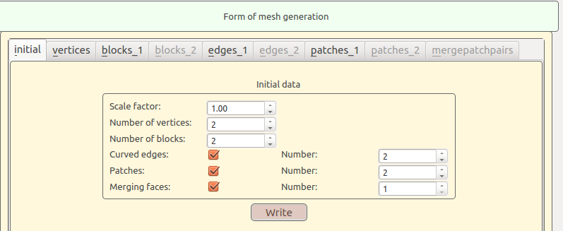
Fig. 8. Example of the filled form "initial"
In accordance with the parameters specified in the form "initial", after saving it, a set of forms is formed: "vertices", "blocks_1", "edges_1", "patches_1". In the forms "blocks_1", "edges_1", "patches_1" only a part of the parameters of blocks "blocks", "edges" and "patches" of the file "blockMeshDict" is indicated. The other part of the parameters is indicated in the "blocks_2", "edges_2", "patches_2" forms, but only after the data in the "blocks_1", "edges_1", "patches_1" forms are saved. The form "mergepatchpairs" becomes available only after saving the data in the form "patches_1".
In fig. 9 shows an example of filling out the form "vertices". For the field of each vertex coordinate, a validator is installed, which allows specifying only numeric values ​​(including negative ones).
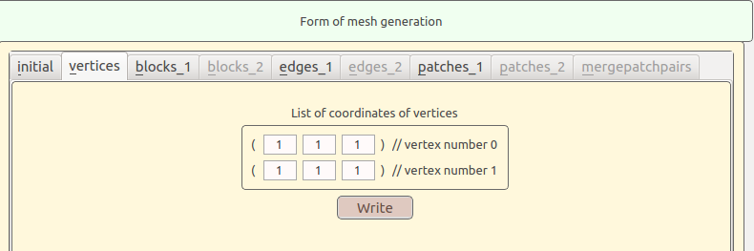
Fig. 9. An example of a filled form "vertices"
In fig. 10 shows an example of filling the form "blocks_1". For the first block, the multigrading option is not installed. For the second block, multi-grading is performed, indicating its direction and the number of sectors. Validators are provided with validators, which allow you to enter only valid data types.
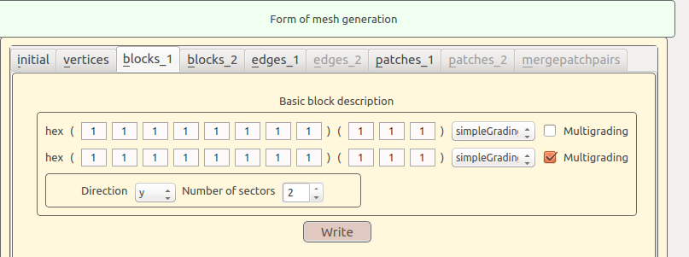
Fig. 10. Example of the filled-in form "blocks_1"
As a result of saving the data in the "blocks_1" form, the "blocks_2" form becomes available, an example of which is shown in fig. 11.
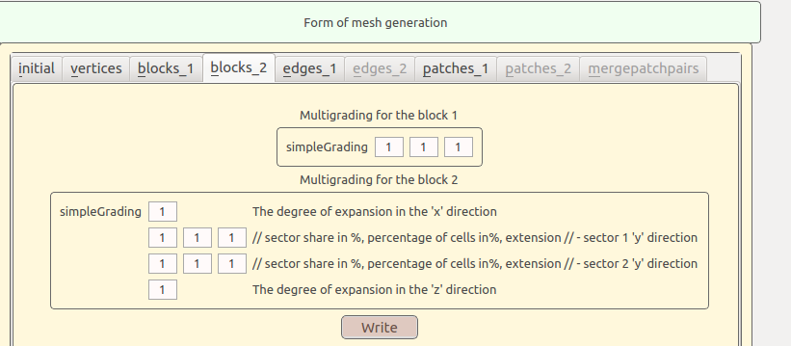
Fig. 11. The results of saving the form data "blocks_2"
In fig. 12 shows an example of filling out the form "edges_1", and in fig. 13 formed after saving its data form "edges_2".
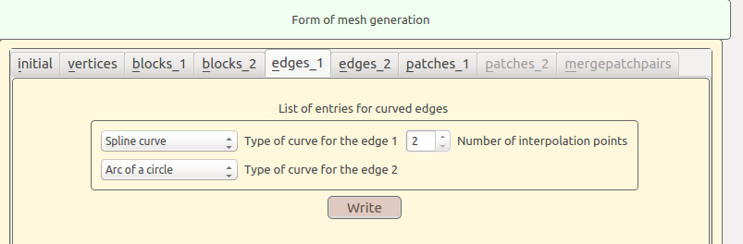
Fig. 12. Results of saving the form data "edges_1"
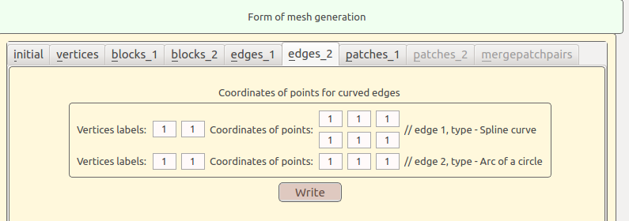
Fig. 13. The results of saving the form data "edges_2"
In Fig. 14, 15 and 16 are examples of filling out the forms "patches_1", "patches_2", "mergepatchpairs".
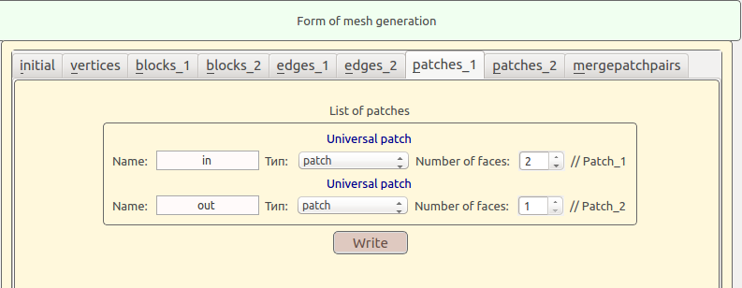
Fig. 14. The results of saving the data of the form "patches_1"
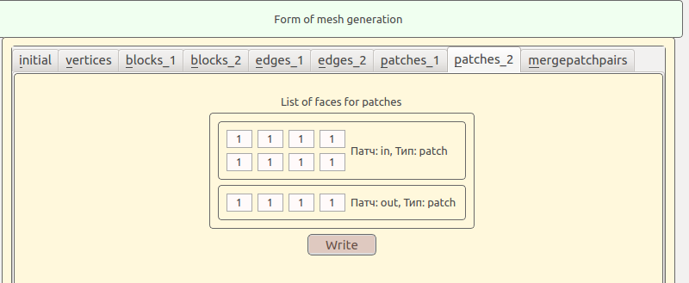
Fig. 15. The results of saving the data of the form "patches_2"
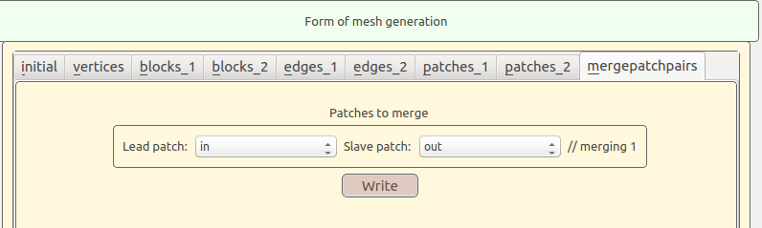
Fig. 16. The results of saving the form data "mergePatchPairs"
If the user is working with one of the existing CM for the current calculation case, after selecting the CM directory, the main program window will be displayed with the already loaded window of the initial data preparation block (fig. 17), in which a set of forms with the parameters of the selected CM will be displayed. Their editing is carried out in a similar way to the approach described earlier (fig. 8-16).
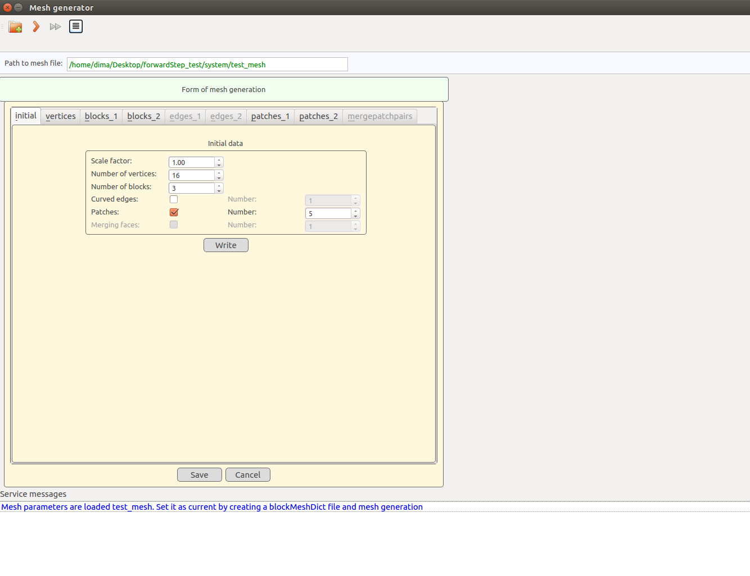
Fig. 17. The main program window after selecting the directory of the existing CM and pressing the "Save" button
After the data of all forms is written to the corresponding service files, you must generate the "blockMeshDict" CM parameter file (the "Save" button) (fig. 18). The structure of the created file will be displayed in the output block.
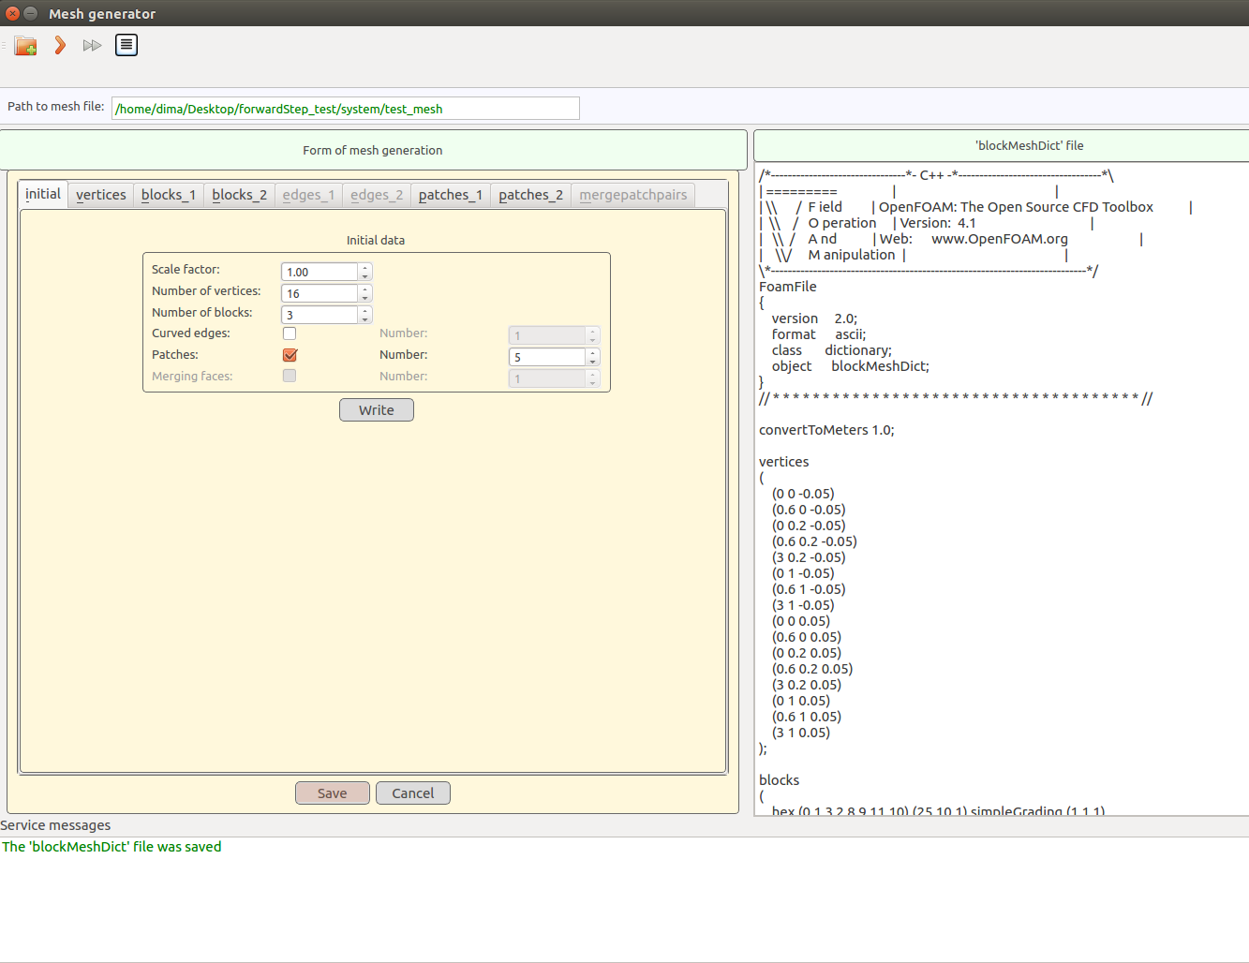
Fig. 18. The main program window after generating the CM parameter file "blockMeshDict"
4) by means of the button "Run mesh generation" (fig. 19), start the corresponding process, an example of the results of which is shown in fig. 20.

Fig. 19. Button to start the process of generating CM.
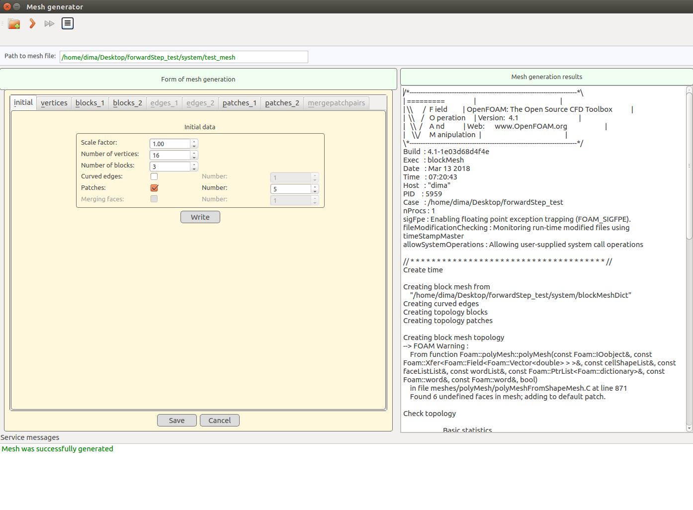
Fig. 20. The main program window after the generation of CM
5) using the button "Run mesh vizualization" (fig. 21), start the corresponding process, an example of the results of which is shown in fig. 22. As a result of the process start, the ParaView 3D visualization package window should open.

Fig. 21. Button to start the process of visualization of CM
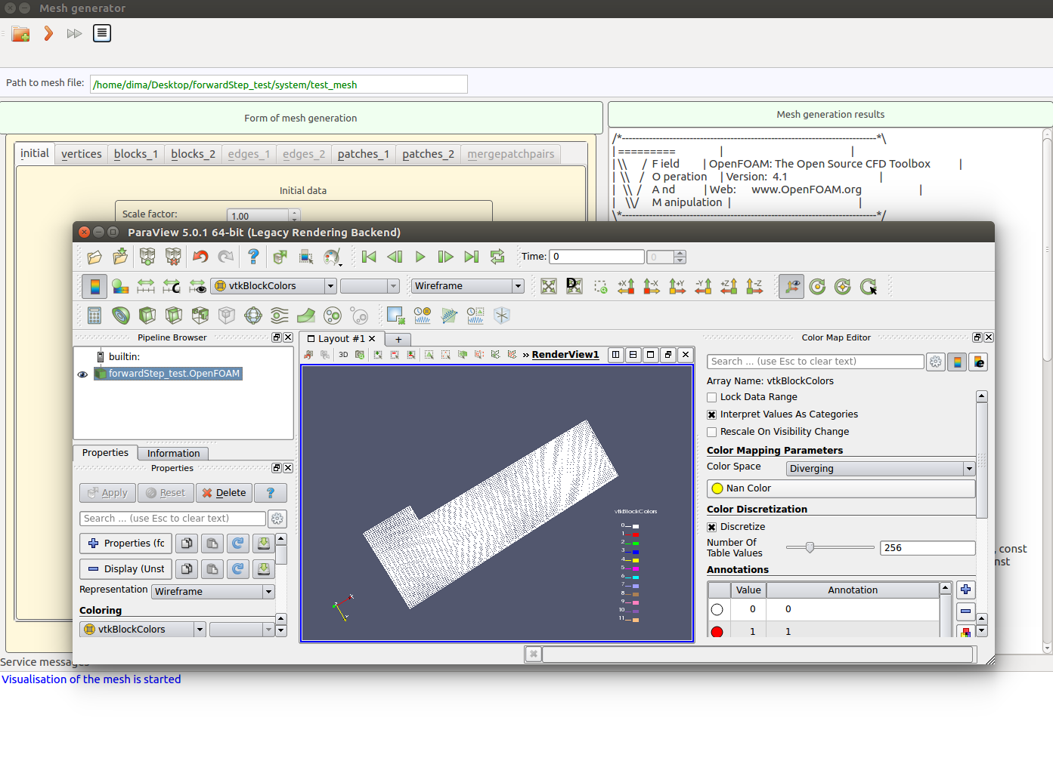
Fig. 22. The main program window after launching the CM visualization process

